TESTING CENTOS SCRIPT

Script Location: /home/gabrielmor/scripts/network_info_dump.sh
Output Location: /home/gabrielmor/network_logs/
Output Filename Format: networkinfo_gabrielmor_2025-9-Nov.txt

Running the Script
- Change directory into where the script is and run: chmod +x network_info_dump.sh to make the script executable
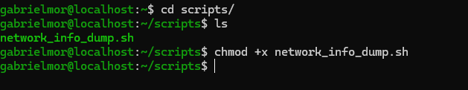
- Then run sudo ./network_info_dump.sh to execute it with sudo
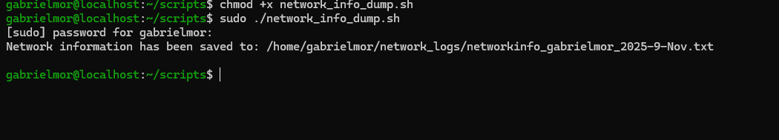

Results:

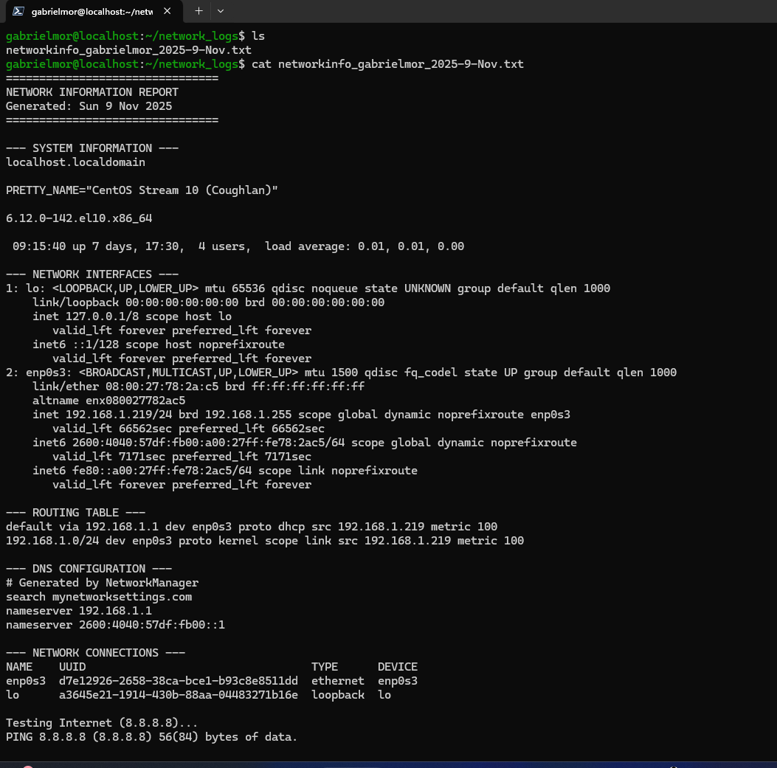

Script Location: /home/gabrielmor/scripts/network_troubleshoot.sh

Prerequisites:
- Script must be executable: chmod +x network_troubleshoot.sh

Results:
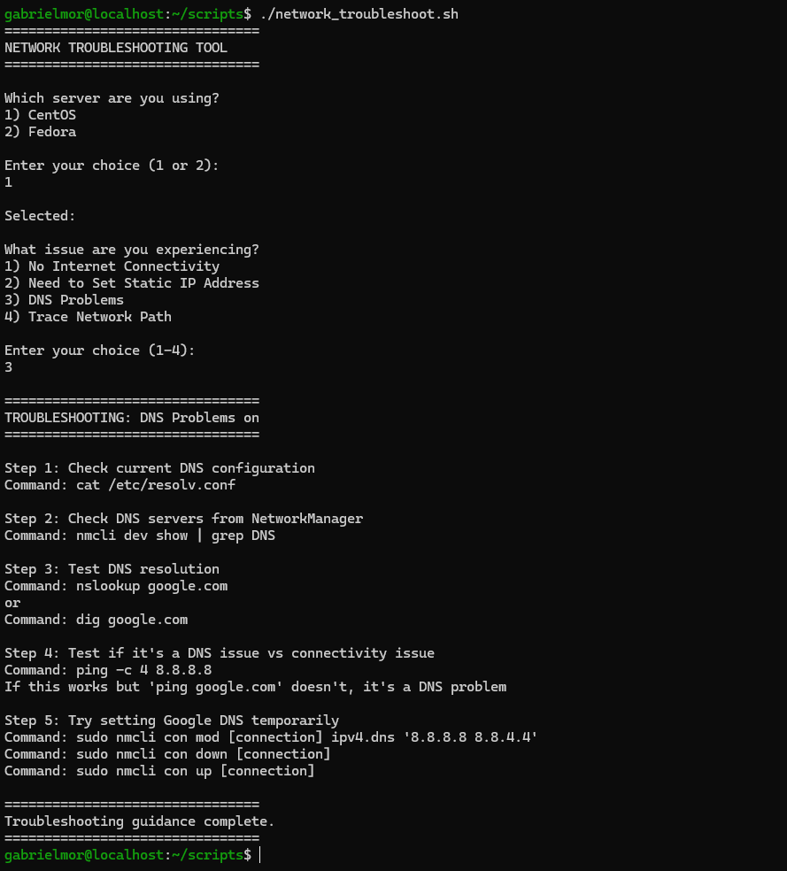

TESTING FEDORA SCRIPT

Script Location: /home/gabe/scripts/network_info_dump.sh
Output Location: /home/gabrielmor/network_logs/
Output Filename Format: networkinfo_gabrielmor_2025-11-11.txt

Running the Script
- Change directory into where the script is and run: chmod +x network_info_dump.sh to make the script executable
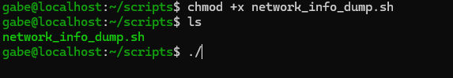
- Then run sudo ./network_info_dump.sh to execute it with sudo
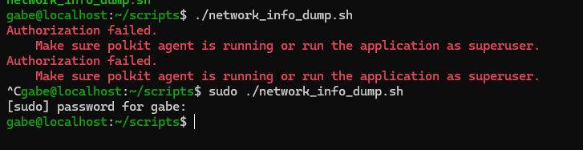

Results:

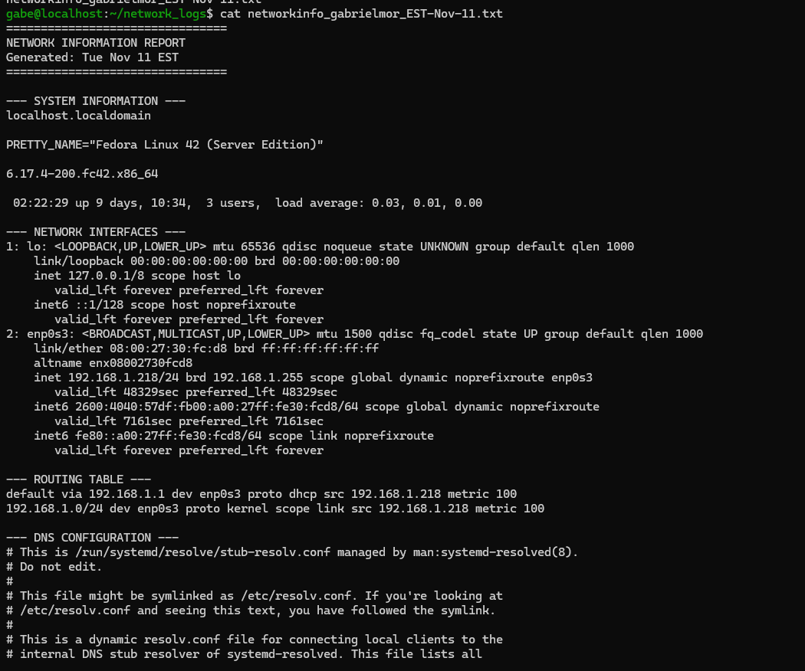

Script Location: /home/gabe/scripts/network_troubleshoot.sh

Prerequisites:
- Script must be executable: chmod +x network_troubleshoot.sh

Results:
